PhD Projects in Planetary Science at Birkbeck, University of London.

Available from October 2020

Project #1: Investigating glacier-like forms on Mars

Supervisor: Dr Ramy El-Maarry

The equatorial and mid-latitudinal regions on Mars contain hundreds of viscous flow features that have been interpreted to be similar to dust covered glaciers by many investigators. In addition, radar studies focusing on these features have concluded that their interiors are composed or nearly pure water ice. These features tend to have various geologic settings including valley fills, concentric crater fills, and lobate aprons. Recent studies have compiled global datasets of these features and derived important and useful global trends with regards to their distribution, surface area, elevation range, and total volume. However, there is still considerable work that can be done to further our understanding of these features, particularly glacier-like landforms such as with regards to geological context, surface morphology, ages or crater retention properties, and long-term evolution. Through this PhD topic, we would like to address the following questions:

- Are there any regional trends in terms of surface morphology within the global dataset of GLFs?
- Are there specific regional or elevation controls on surface morphology and long-term evolution of GLFs on Mars?
- Did all the GLFs on Mars form at the same period (last obliquity period) or is there evidence for formation through multiple obliquity cycles or periods?

The successful PhD candidate is expected to utilise high resolution remote sensing datasets, including high resolution images and digital terrain models to address these questions. The PhD candidate would also be able to take advantage of Birkbeck’s involvement with numerous remote sensing missions to plan and acquire images specific to their project, particularly from the NASA Mars Reconnaissance Orbiter HiRISE camera, and the ESA ExoMars Trace Gas Orbiter CaSSIS camera. The successful candidate should have a background in geology or a relevant science. Experience in using remote sensing data or GIS software is would be preferable, but is not essential.
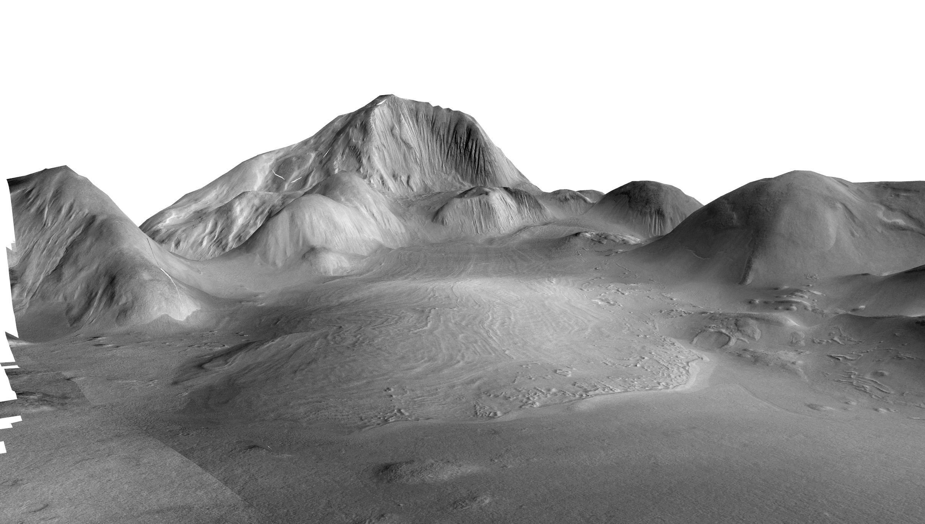

Suggested preliminary reading:

Souness C., et al. (2012). An inventory and population-scale analysis of martian glacier-like forms. Icarus 217, 243-255. https://doi.org/10.1016/j.icarus.2011.10.020.

B. Hubbard, C. Souness, and S. Brough, (2014). Glacier-like forms on Mars. The Cryosphere 8, 2047-2061. https://www.the-cryosphere.net/8/2047/2014/tc-8-2047-2014.pdf

S. Brough, B. Hubbard, A. Hubbard, (2019). Area and Volume of mid-latitude glacier-like forms on Mars. Earth and Planetary Science letters 507, 10-20. https://doi.org/10.1016/j.epsl.2018.11.031.

Project #2: Investigating desiccation-like cracks on Mars

Supervisor: Dr Ramy El-Maarry

Surface polygonal fracture patterns are a common feature on Mars that span almost all latitudes, a wide range of size scales, and a variety of geologic settings. Due to the prevalent cold and dry climate on Mars, which has probably dominated for billions of years, there has been a tendency among the planetary science community to classify most of the polygonal patterns on Mars as
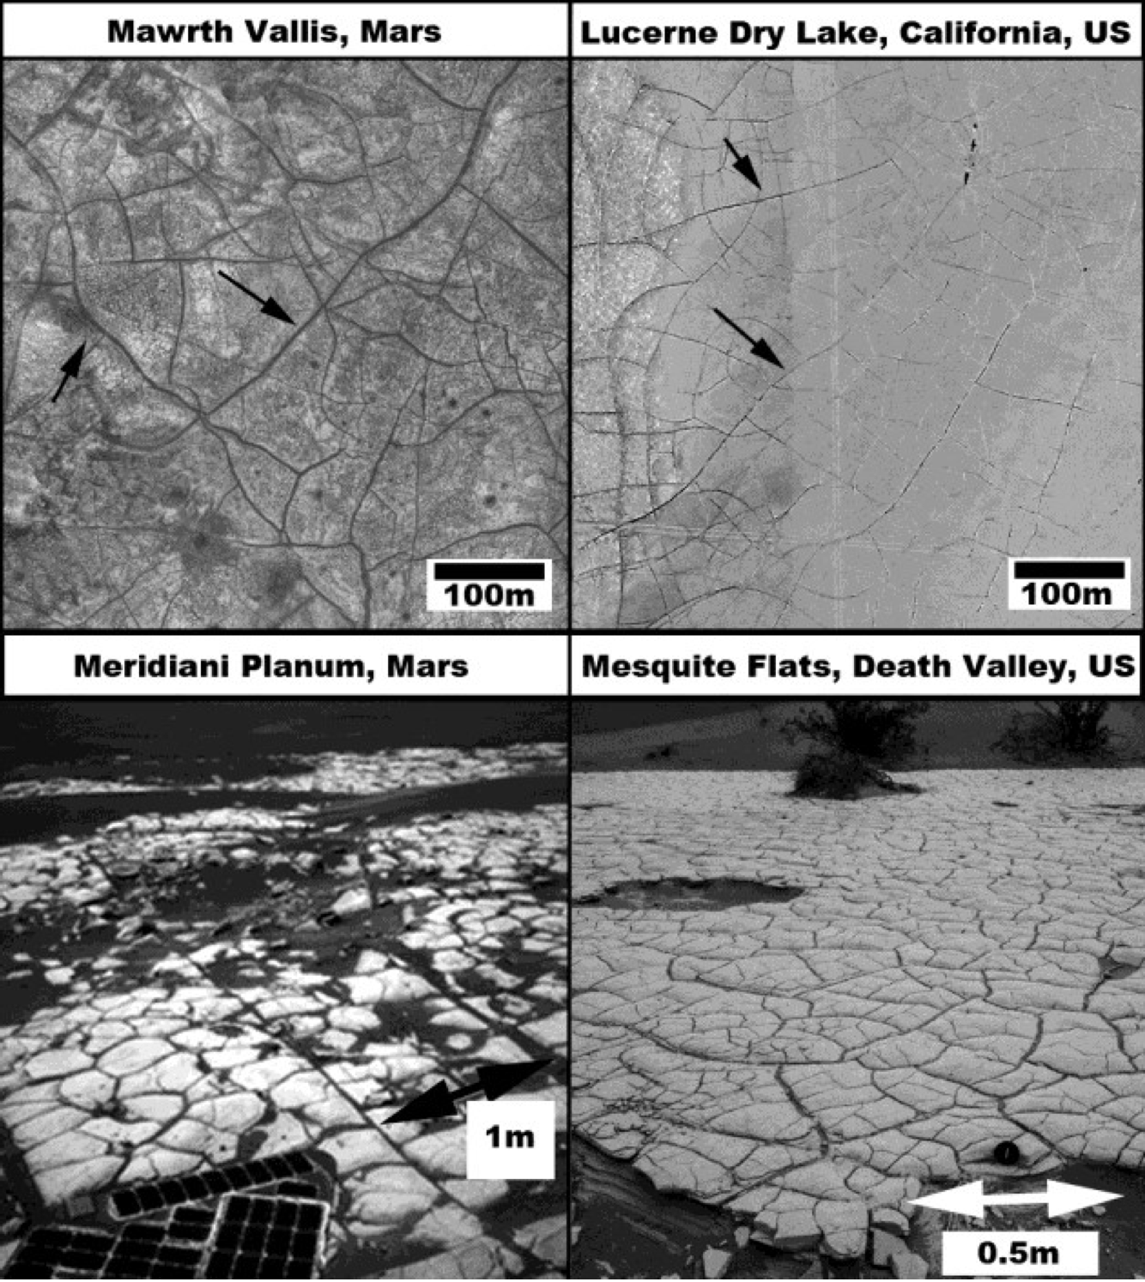
periglacial features that develop as a result of fractures developing not the surface due to large seasonal changes in surface and near-subsurface temperature. However, with the enhanced global coverage of the surface with high spatial resolutions, many more fracture patterns were identified on the surface. These polygonal patterns are concentrated in the equatorial/near- equatorial regions, cover a wider range of sizes than thermal contraction polygons, and are located in association with clay minerals, and salts such as sulphates and chlorides. In addition, small cm- sized polygonal patterns have been observed from the ground by the Opportunity rover in Meridiani, and by Curiosity in Gale crater (see figure). Such fractures have been interpreted as potential desiccation polygons (PDPs) and inferred to have developed when wet sediments (such as in a recently dried lake bed) desiccated and created fracture patterns that resemble typical mud cracks.
Figure 1. Potential desiccation polygons identified on Mars from orbit and from the ground and a comparison with similar features on Earth.
While initial global and regional studies have been carried out to characterise such features, more work is needed to investigate the variety of geological settings of PDPs both on the large scale (i.e. observable from orbit) and small scale (observed in-situ by rovers). The main objectives of this PhD topic would be to combine data analysis and fieldwork to:

- Constrain the age of formation of PDPs and investigate time span of PDP production on Mars.
- Constrain the geologic settings in which large PDPs form versus small ones focusing on regional morphometric analysis
- Understand how PDPs are preserved on Mars.

The successful PhD candidate is expected to utilise high resolution remote sensing datasets, including high resolution images and digital terrain models to address these questions. The PhD candidate would also be able to take advantage of Birkbeck’s involvement with numerous remote sensing missions to plan and acquire images specific to their project, particularly from the NASA Mars Reconnaissance Orbiter HiRISE camera, and the ESA ExoMars Trace Gas Orbiter CaSSIS camera. Fieldwork could be planned and is expected to occur in dried lakes in the USA, and possibly in Death Valley National Park. The successful candidate should have a background in geology or a relevant science. Experience in using remote sensing data or GIS software is would be preferable, but is not essential.

Suggested preliminary reading:

El-Maarry M.R., W.A. Watters, Z. Yoldi, A. Pommerol, D. Fischer, U. Eggenberger, and N. Thomas, (2015). Field Investigation of Dried Lakes in Western United States as an Analogue to Desiccation Fractures on Mars. J. Geophys. Res. Planets 120, doi:10.1002/2015JE004895.

El-Maarry M.R., W. Watters, N. McKeown, J. Carter, E. Noe Dobrea, J. Bishop, A. Pommerol, N. Thomas, (2014). Potential Desiccation Cracks on Mars: A Synthesis from Modeling, Analogue-Field Studies, and Global Observations, Icarus 241, 248–268.

El-Maarry M.R., A. Pommerol, N. Thomas, (2013). Analysis of polygonal cracking patterns in chloride-bearing terrains on Mars: Indicators of ancient playa settings, J. Geophys. Res. Planets 118, 2263–2278.

Project #3: The distribution and evolution of water in the lunar interior

Supervisor: Dr Eleanor Jennings

Secondary supervisor: Dr Andrew Thomson (UCL)
Additional supervisors: Prof. Ian Crawford (Birkbeck)

Project background
The extent to which the lunar interior contains water has become a major topic of research^{1–4}. Whereas the Moon was once thought to be completely dry, recent high-quality measurements of various lunar volcanic products including glasses, melt inclusion and apatite phenocrysts provide tantalising glimpses of the presence of some water in the Moon’s deep interior^{1,2}. The bulk water content of the Moon is important for constraining models of its formation⁴. To quantify water in a planetary interior, one can back-calculate from its magmatic products (lavas etc.) by using partition coefficients and some assumptions about its source lithology, melting behaviour and subsequent fractionation⁵. However, this is currently difficult because of:
- Limited knowledge of the mineralogy and melting behaviour of the diverse mantle source lithologies that are responsible for the large diversity of primary lunar magmas. Lithological diversity on the Moon is thought to reflect magma ocean crystallisation processes.
- Lack of moon-appropriate partition coefficients for water in mantle mineral and melts (i.e. partition coefficients for water at low fO₂, and for high-TiO₂ compositions).
- Lack of knowledge of how water might be heterogeneously distributed between different source lithologies.
In this project, the student will attempt to quantify the water content of different lunar mantle lithologies from published measurements of lunar materials. This will be used to provide constraints on both the bulk water content of the moon, and the evolution of its distribution through interior differentiation and subsequent volcanism.
Proposed method
- Perform experiments to constrain new partition coefficients for water in moon-appropriate systems. These experiments are expected to be challenging because they involve water at low-fO₂ conditions (piston cylinder +/- multianvil; UCL, e.g.³)
- Analyse major elements and water contents and water speciation in experimental products (SIMS, Edinburgh; FTIR, UCL; EPMA, Birkbeck)
- Create a model of lunar magma ocean fractionation and constrain the melting behaviour of the different mantle lithologies. Modelling will be performed in the thermodynamic calculation software thermocalc⁶ using recently-developed silicate liquid models (Birkbeck).
- Combine thermodynamic modelling, new partition coefficients, and published water contents of lunar materials to map out water content in the lunar interior.
Training and pre-requisite knowledge
Training will be provided in all relevant methods. The student must have a degree in a physical science (planetary science, geology, material science, chemistry or physics) and some knowledge of igneous processes. Whilst specific experience in experiments, analytical work and thermodynamic modelling is not required, this project includes numerical elements and would suit a student who enjoys learning new computational methods in addition to lab work.
References
1. Saal, A. E. et al. Volatile content of lunar volcanic glasses and the presence of water in the Moon’s interior. Nature 454, 192–195 (2008).
2. Anand, M., Tartèse, R. & Barnes, J. J. Understanding the origin and evolution of water in the Moon through lunar sample studies. Philos. Transact. A Math. Phys. Eng. Sci. 372, (2014).
3. Lin, Y., Tronche, E. J., Steenstra, E. S. & Westrenen, W. van. Evidence for an early wet Moon from experimental crystallization of the lunar magma ocean. Nat. Geosci. 10, 14–18 (2017).
4. Hauri, E. H., Saal, A. E., Rutherford, M. J. & Van Orman, J. A. Water in the Moon’s interior: Truth and consequences. Earth Planet. Sci. Lett. 409, 252–264 (2015).
5. Elkins-Tanton, L. T. & Grove, T. L. Water (hydrogen) in the lunar mantle: Results from petrology and magma ocean modeling. Earth Planet. Sci. Lett. 307, 173–179 (2011).
6. https://hpxeosandthermocalc.org/the-thermocalc-software/ (2019).

