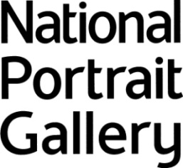

AHRC/CHASE Collaborative Partnership Award

Fully-funded PhD studentship.

Cultural Snipers: Photographic Portraiture in Britain, 1970-1990.

In collaboration with Birkbeck, University of London and the National Portrait Gallery.

Closing date for applications: 12 noon, 10 May 2019

Personal Details:
Surname:
Other Names (in full):
Date of Birth:
Nationality:
Title (e.g. Dr, Miss, Mrs, Mr):
Email:
Telephone:

Previous Higher Education:
Degrees or other qualifications held:
University or College | Subject(s) Studied | No. of Years Studied | Title | Class/Grade | Date of Award

Qualifications for which you are at present studying:
University or College | Subject(s) Studied | No. of Years Studied | Title | Date of Final Examination

Professional or other qualifications:
Give details, where obtained, and dates:

Particulars and date of any relevant full-time employment:

Other Relevant Information (including publications, prizes and awards):

Please provide a brief statement (not exceeding 2000 words) in support of your application, commenting on your qualifications for the studentship.

References (please ask your referees to send their references directly to Anthony Shepherd (SoAFA@bbk.ac.uk), the team leader for the MPhil/PhD programmes in the School of Arts at Birkbeck College, by the deadline)

List names, titles and addresses of TWO referees who can comment on your academic ability and suitability for this award. The first referee should be an academic who has direct knowledge of your most recent degree.

First Referee:  Name:  Address:  Email:  Status: |  | Second Referee:  Name:  Address:  Email:  Status:

Both applications and references should be sent to Anthony Shepherd (SoAFA@bbk.ac.uk), no later than 12 noon, 10 May 2019.

