Recite Me

What is Recite Me?
Recite Me is an assistive toolbar. We have added Recite Me to our website to make it more accessible for people with disabilities such as dyslexia or visual impairment, as well as for speakers of languages other than English.

How do I open Recite Me?
You can open the Recite Me toolbar by clicking on the Accessibility link at the top of any page on our site.
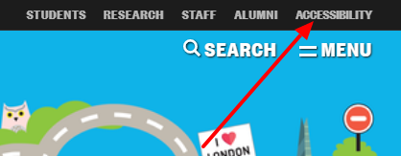
Once you click on this link the Recite Me tool bar will appear, and it will stay at the top of the page as you browse the site, until you close it.

What does Recite Me do?
Recite Me can:
- Read our site aloud to you.
- Change the size of the text.
- Change the font.
- Change the colours of the background and text.
- Search for word definitions.
- Give you a plain text alternative.
- Translate the site into one of over a hundred languages.
- Save your preferred settings for next time you visit our site.

How do I use Recite Me?
These buttons let you choose text for Recite Me to read aloud to you.
These buttons let you make changes to the font size or change to a different font.
This button lets you change the background, text and link colours.
This button lets you translate the text into a number of different languages, some of which can be read aloud by the software.

Find out more
Full instructions for using Recite Me can be found on their website.

Tell us what you think
We would love to know what you think of Recite Me and whether it has helped you to use the Birkbeck website. Contact Birkbeck ITS if you have any comments or questions

