Domesticating Energy
Energy environments inside and outside the home

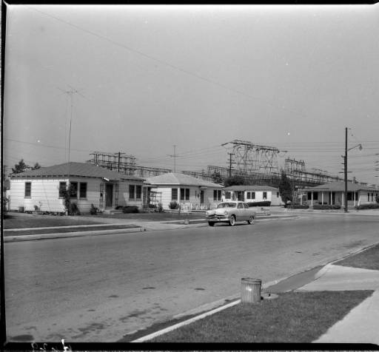
Distribution - substation - Laguna Bell - behind houses. n/d Southern California Edison Photographs and Negatives, Huntington Library, Art Collections and Botanical Gardens.

25-26 May 2017, Nihon Room, Pembroke College, University of Cambridge

Conveners: Paul Warde (University of Cambridge); Rebecca Wright (University of Sussex); Frank Trentmann (Birkbeck College)

Organized by the AHRC project, “Material Cultures of Energy” (Birkbeck College), Pembroke College, University of Cambridge and the Joint Centre for History and Economics at Cambridge and Harvard University.

Thursday 25th of May

14:00-14:30 Welcome and Coffee

14:30-15:00 Introductions

15.00-16:15 Panel 1: Households and energy flows/systems.
Chair and Commentator
Frank Trentmann, Birkbeck College

Sabine Barles, Université Paris 1, Panthéon-Sorbonne
“Consuming energy in Paris during the 18th century: from forests to homes”

Paul Warde, University of Cambridge
“Firewood use and energy transitions: an international comparison”

16:15-16:30 Tea and Coffee

16:30-18:15 Panel 2: Energy use and domestic practices
Chair and Commentator
Sandy Skelton, University of Cambridge

Hal Wilhite, University of Oslo
“The global transformation towards high-energy home cooling practices and thoughts on enabling low-energy pathways”

Rebecca Wright, University of Sussex

“Consuming energy futures in the home”

Christopher Groves, Cardiff University

“Practices that matter – linking energy use, attachment and identity”

18:30-19:15 Drinks Reception in the Christopher Smart Room, E Staircase, Pembroke College

19:30 Dinner (Loch Fyne Seafood and Grill)

Friday 26th of May

09:00-10.45 Panel 3: Making community (1)
Chair and Commentator
Hanaan Marwah, CDC Group

Roxana Morosanu, University of Cambridge
“Energy and Homes: Conflicts, Contradictions and Collaborations”

Ian Miller, Harvard University
“Who Owns Watt? Electricity Theft and the Political Economy of Japanese Modernity"

Sorcha O'Brien, Kingston University
“Researching Housewives, Electrical Products and Domesticity in 1950s and 1960s Rural Ireland”

10.45-11:00 Tea and Coffee

11:00-12:45 Panel 4: Interfaces and Controls
Chair and Commentator
Vanessa Taylor, University of Greenwich

Magnus Lindmark, Umeå University
“Heat in a Cold Climate: Energy Choices in the Scandinavian North”

Sam Wetherell, Columbia University
"Only Disconnect: District Heating and the Strange Afterlife of Social Democracy"

Charlotte Johnson, University College London
“The metered home: experimenting with smart meters in Tower Hamlets”

12:45-13:30 Lunch

13:30-14.45 Panel 5: Making Community (2)
Chair and Commentator
TBA

Ute Hasenöhrl, Universität Innsbruck
“Colonial and postcolonial energy landscapes: The Indian case, 1858-2017”
Sarah Strauss, University of Wyoming
“The Retrofuturist Imaginaries of Iconic Structures: Shifting Energy Praxis from Abbotsford to Auroville”

14.45-15:00 Tea and Coffee

15:05-16:00 Panel 6: Concluding discussion
Chair and Commentator
Harriet Ritvo, Massachusetts Institute of Technology

