LADS dyslexia screening software

- Log on to a computer in the workstation rooms or the library using your username and password.

- Make sure you have headphones on and that they are working.

- Click on the Start menu at the bottom left of the screen.
- Type LADS into the Start menu edit box.
- The LADS link appears in the list above. Click on it.
The Test Module Appears
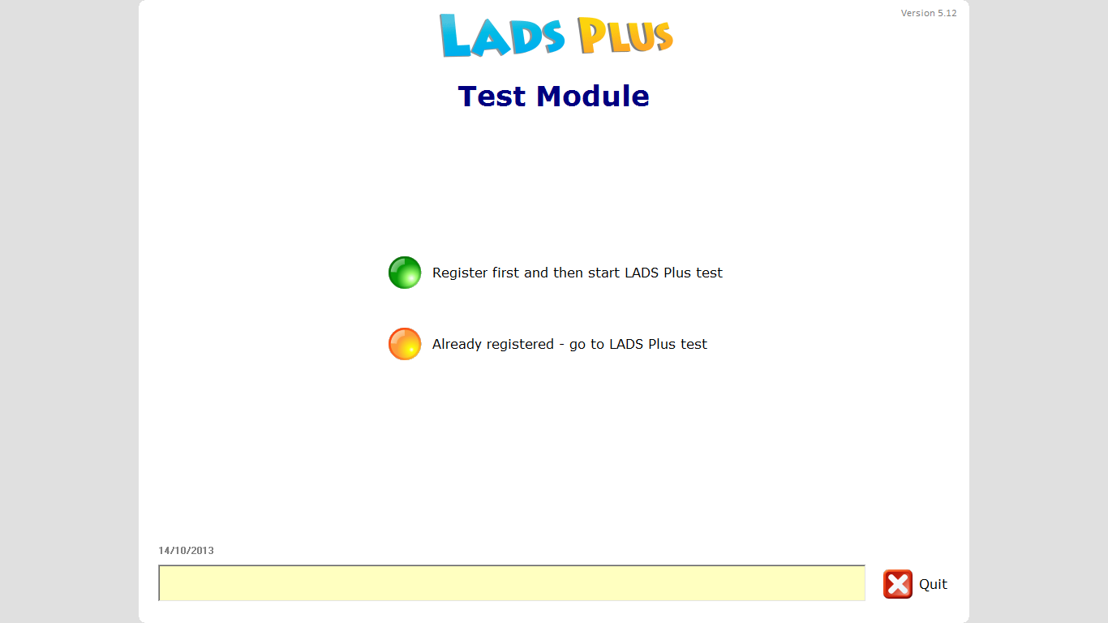
- Click on the green button – Register first and then start LADS Plus test
The Registration Screen Appears:
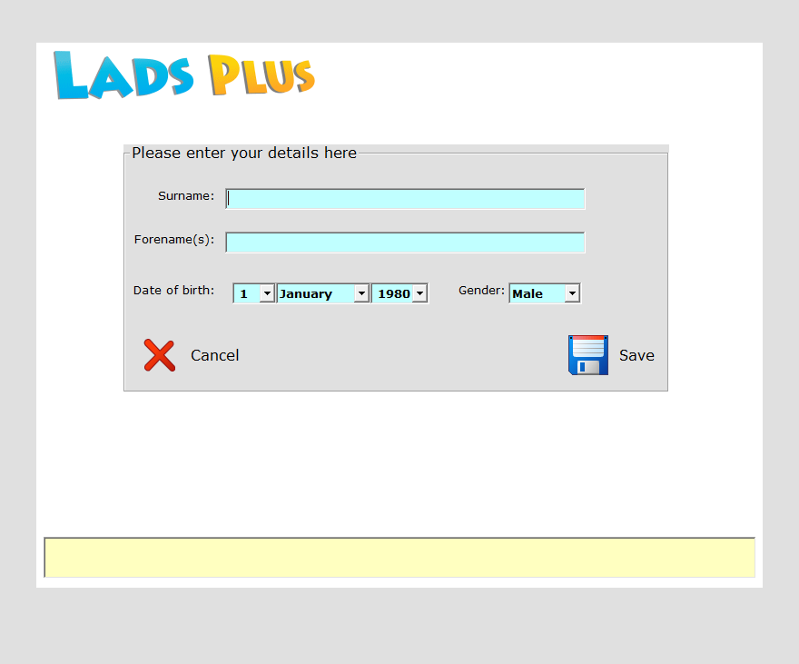
- Fill in your Surname, Forename, Date of Birth and Gender, then click on Save
The confirmation dialogue appears
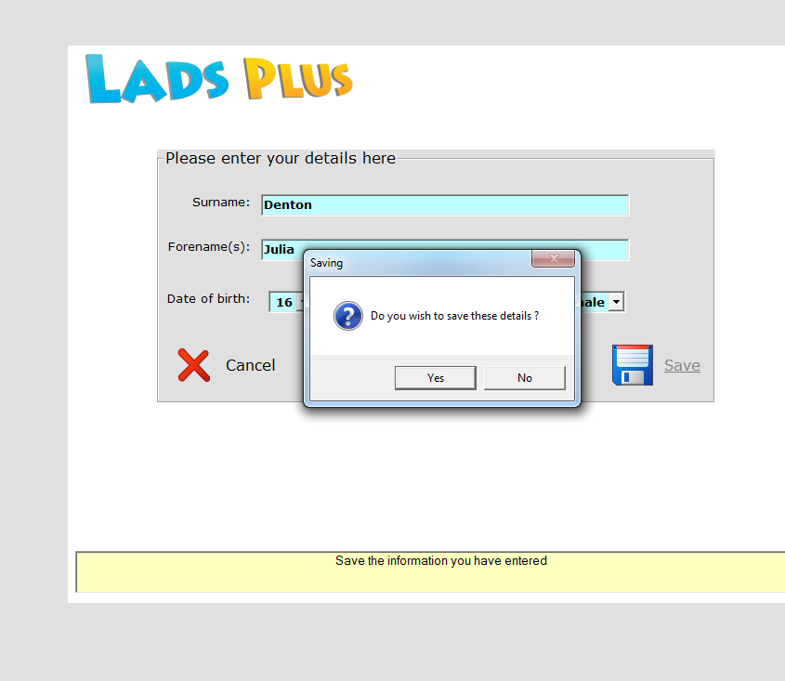
- Click on Yes to Save these details. (Note that help is offered in the pink section at the bottom of the screen).

The Tests Menu appears with your name at the top
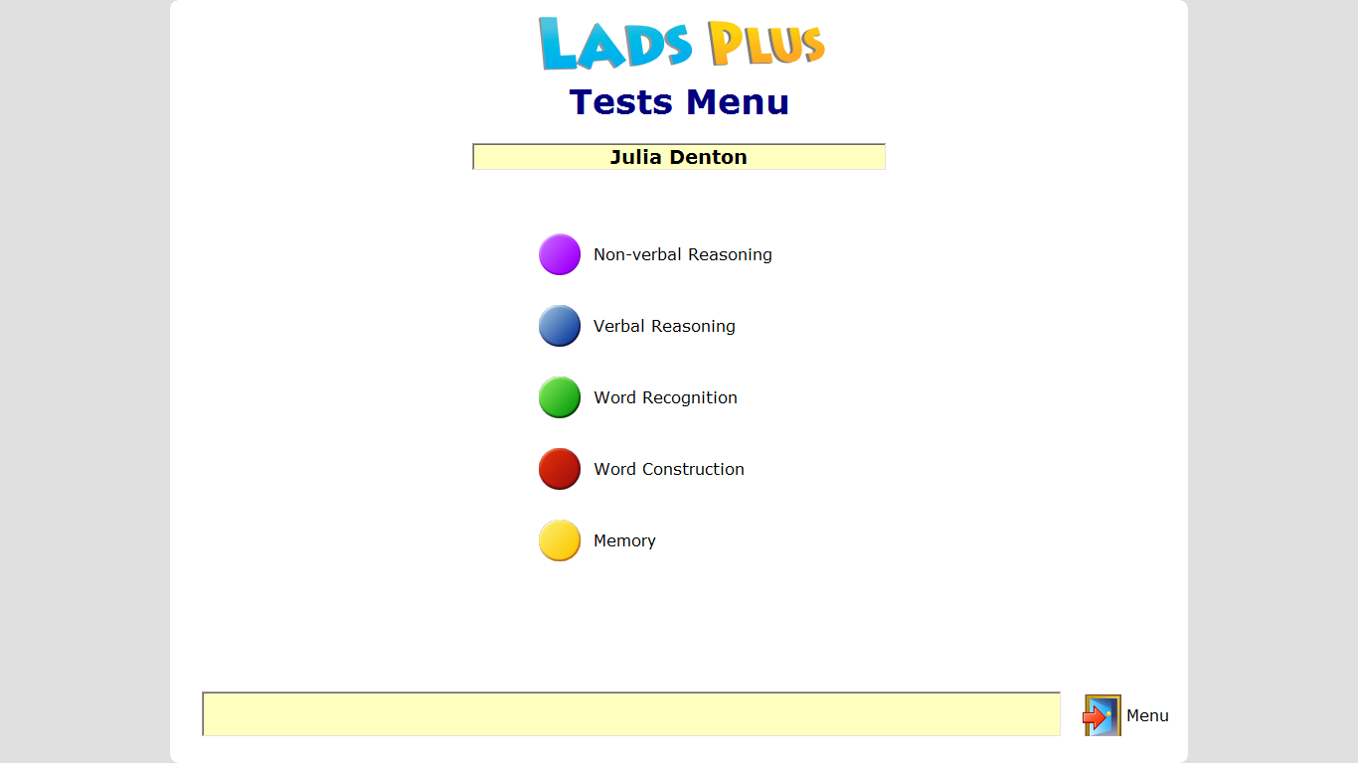
- Click on Reasoning – you need to do this test first
The Reasoning Screen Appears.
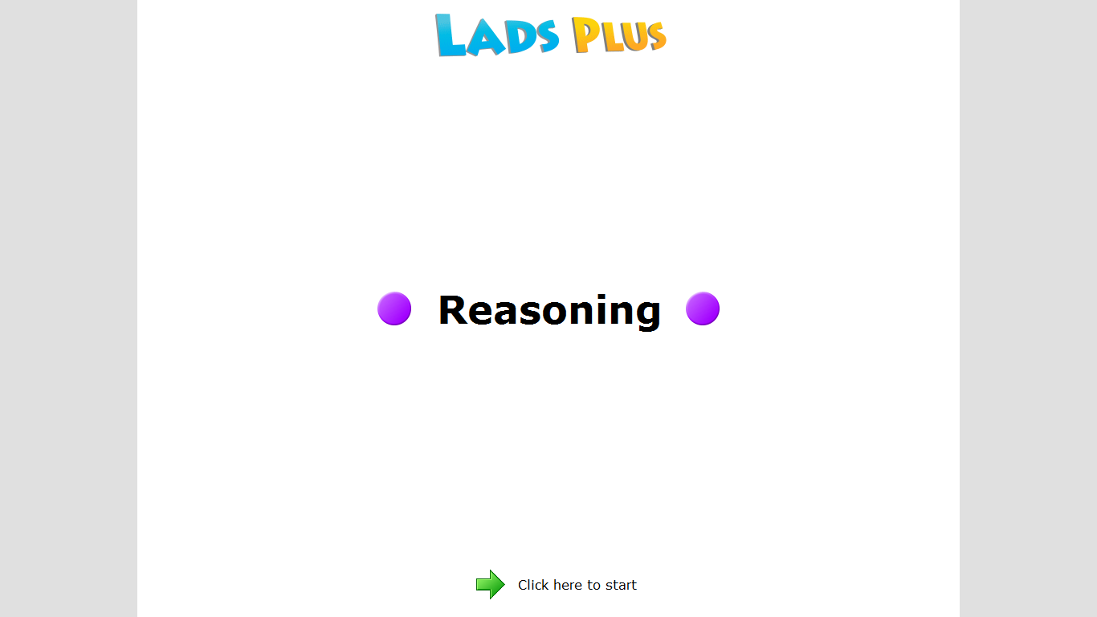
- Make sure you have the headphones on and then Click on Click here to Start
The first test page appears:
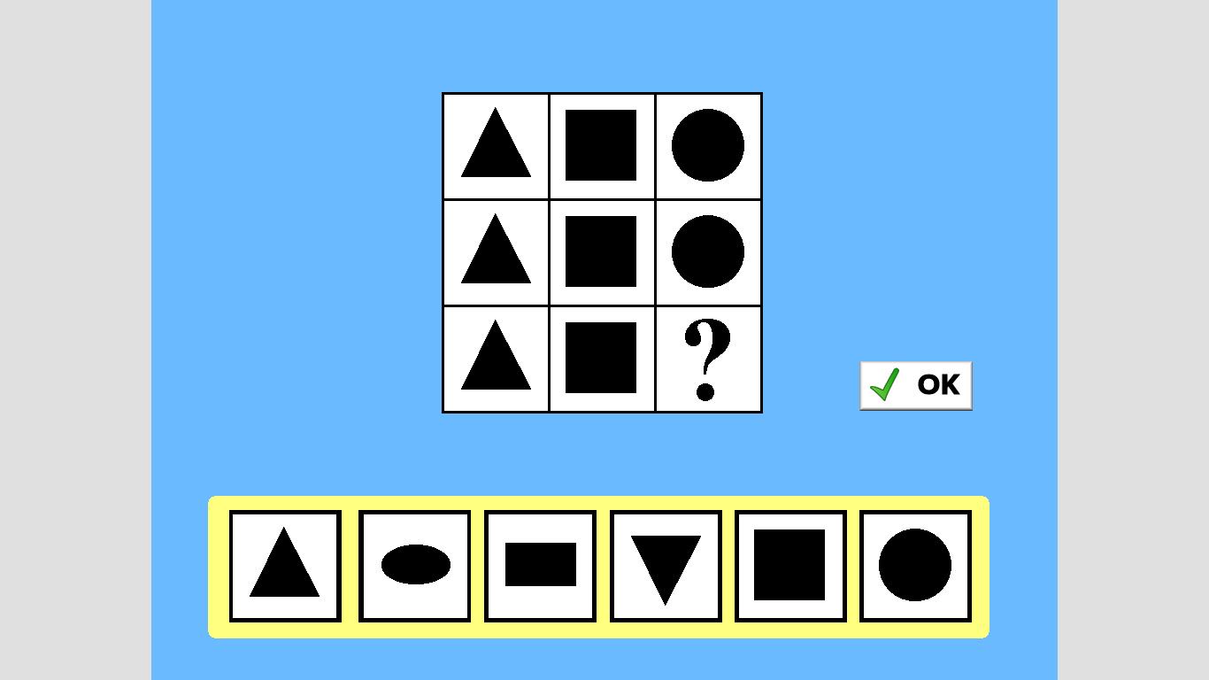
You will hear instructions.
- Follow the instructions and complete the test.
When you finish you get a thank you screen
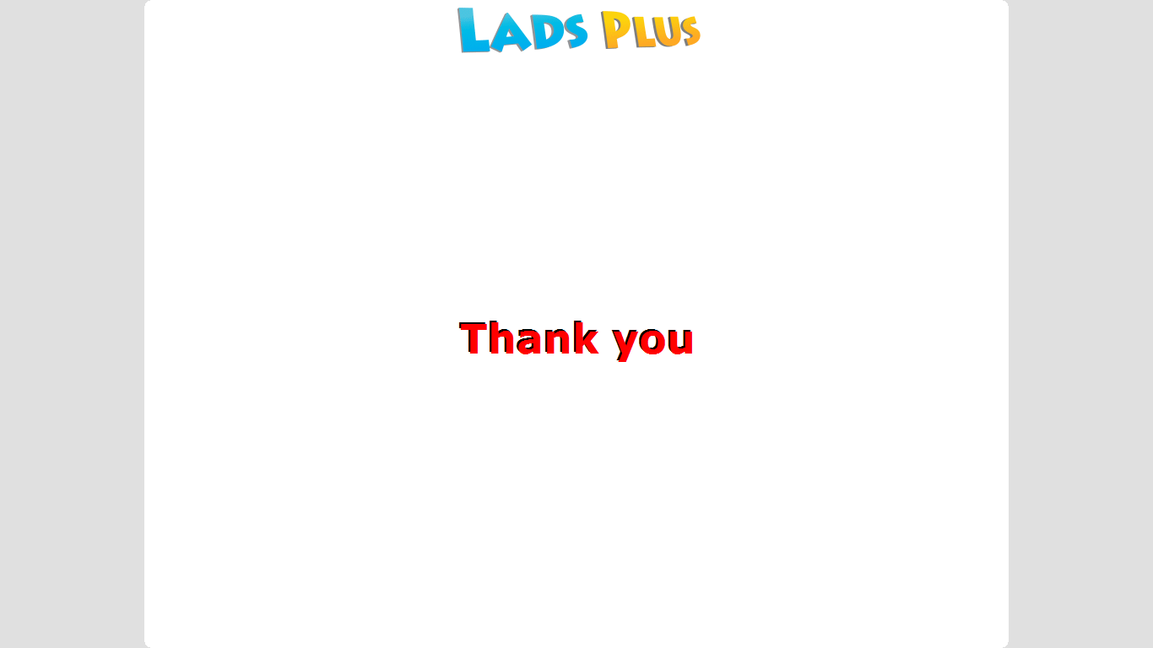
You are then returned to the test menu and a tick appears after the test that you have completed.
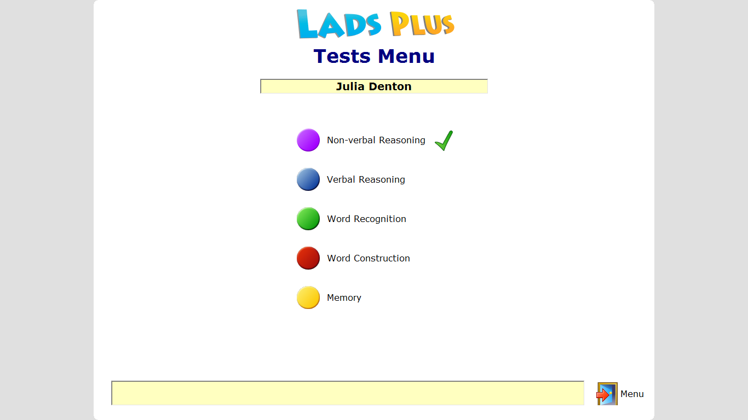
- If you want to continue through the tests until you have finished them all go to step 13.
- If you want to stop before you have finished all of the tests then click the Menu icon.
You will receive the following warning: All the test have not been completed – are you sure that you want to exit?
click OK.
When you return to complete the tests go to step 15.
13. If you want to finish the tests in one session continue to take the tests by clicking on the next test to be done.
When you have finished all of the tests you will be returned to the Test Module Screen.
14. Click Quit
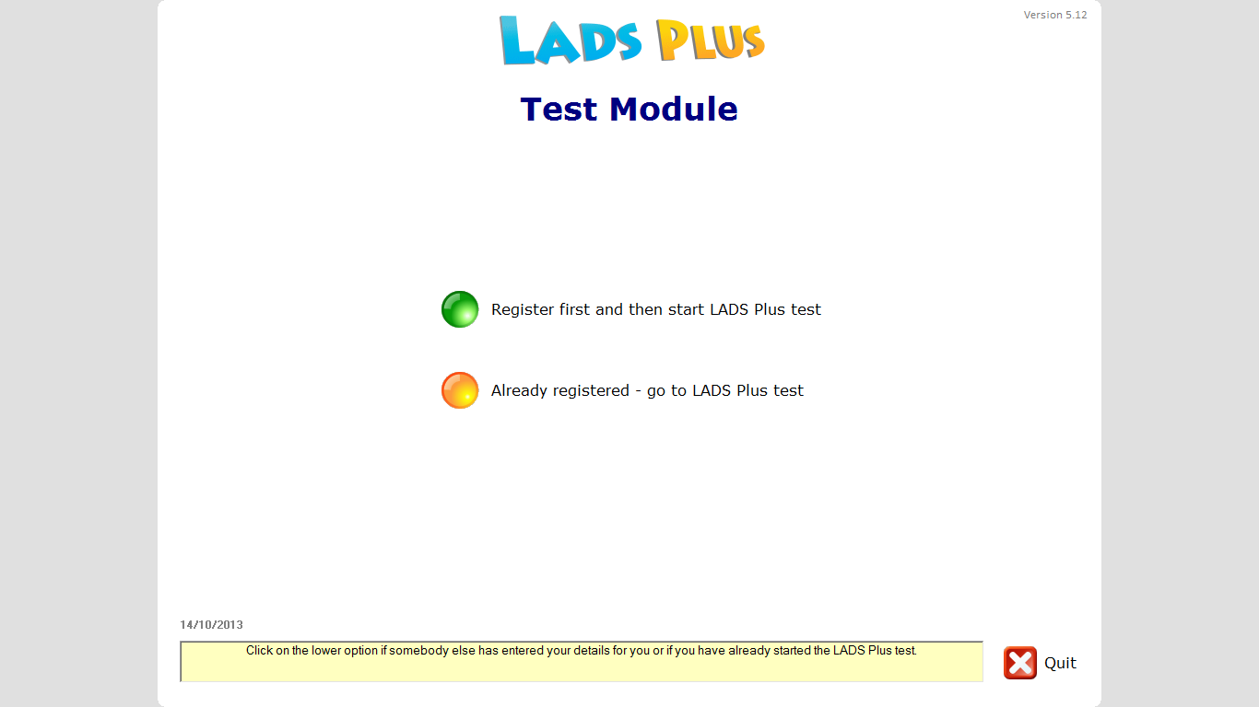

15. Finishing Tests taken on a previous occasion.

Follow Steps 1 – 4 above. This will take you to the Test Module window
16. Select Already registered – go to LADS Plus test
You will see the Security check screen
17. Select your name using the Name: drop down list, and then enter your date of birth. Click on Next
You will see the LADS test menu with your name displayed
Continue to take the tests by clicking on the next test to be done. Continue with the tests until you have completed them all.
You will be returned to the Test Module screen.
14. Click Quit
You will receive your results from the disability office.

